# Setting Multi-Level Indexes

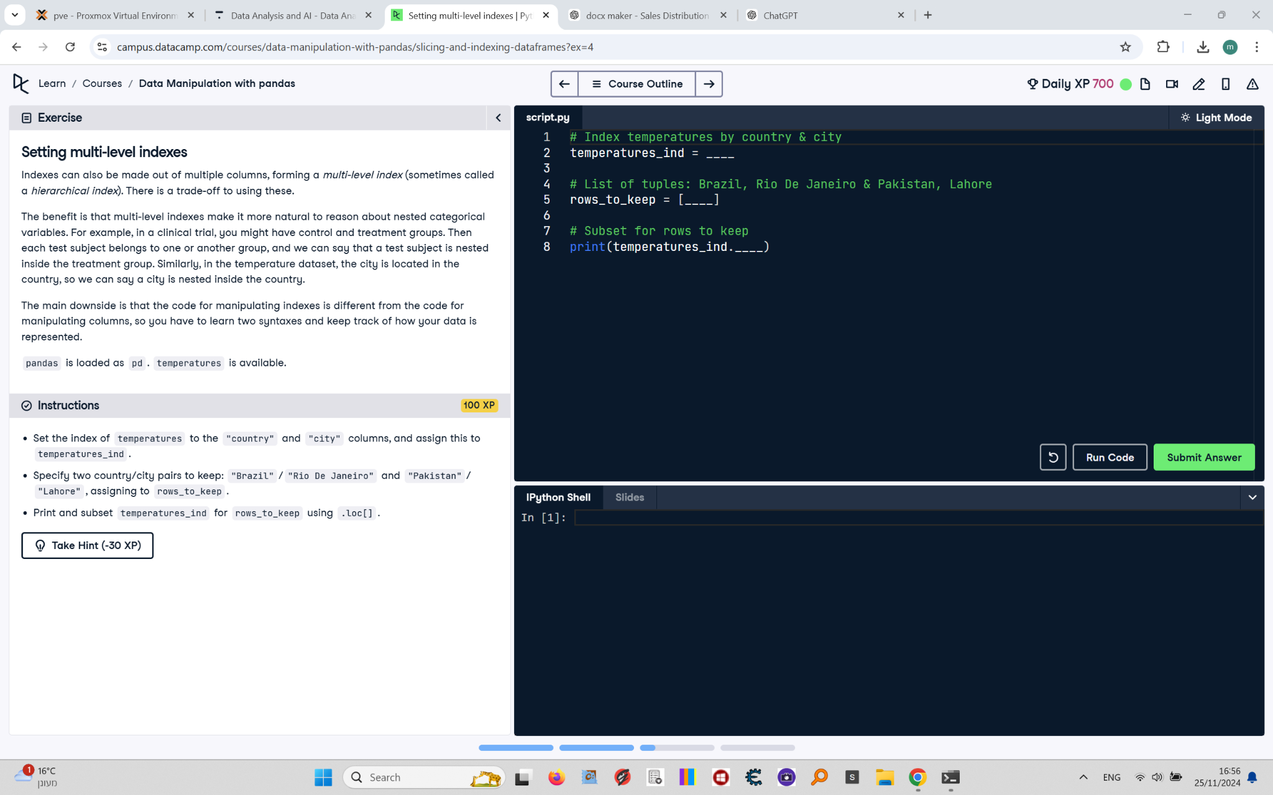

Indexes can also be made out of multiple columns, forming a multi-level index (sometimes called a hierarchical index). There is a trade-off to using these.  
  
The benefit is that multi-level indexes make it more natural to reason about nested categorical variables. For example, in a clinical trial, you might have control and treatment groups. Then each test subject belongs to one or another group, and we can say that a test subject is nested inside the treatment group. Similarly, in the temperature dataset, the city is located in the country, so we can say a city is nested inside the country.  
  
The main downside is that the code for manipulating indexes is different from the code for manipulating columns, so you have to learn two syntaxes and keep track of how your data is represented.  
  
pandas is loaded as pd. temperatures is available.

## Final Answer

# Index temperatures by country & city  
temperatures_ind = temperatures.set_index(["country", "city"])  
  
# List of tuples: Brazil, Rio De Janeiro & Pakistan, Lahore  
rows_to_keep = [("Brazil", "Rio De Janeiro"), ("Pakistan", "Lahore")]  
  
# Subset for rows to keep  
print(temperatures_ind.loc[rows_to_keep])